Steps to install AUTO-07p on Windows 10
Notes:
- Administrator privileges required. Run all installers as administrator
- Computer username must contain no spaces

PART I – Install prerequisites
- Install Python 2.6. It is an older version, but better compatible with Auto.
Here’s the link (32-bit version, this works better, even if your PC is 64-bit): https://www.python.org/ftp/python/2.6.6/python-2.6.6.msi
Perform the default installation (for all users) as per instructions. Don’t change the installation folder.
- Install NumPy. Follow default instructions. Here’s the link: https://sourceforge.net/projects/numpy/files/NumPy/1.6.1/numpy-1.6.1-win32-superpack-python2.6.exe/download
- Install matplotlib. Follow default instructions. Here’s the link (32-bit version): https://sourceforge.net/projects/matplotlib/files/matplotlib/matplotlib-1.0/matplotlib-1.0.0.win32-py2.6.exe/download
- Install MinGW. Here’s the link: https://www.dropbox.com/s/ay84278y2zl5rrc/mingw-get-inst-20110530.7z?dl=0
WinRAR may be required to extract. Choose the pre-packaged installation. Select all optional downloads.
- Check if MinGW is correctly installed. Open C:\MinGW\msys\1.0\msys.bat and try out Linux commands to see if they work. It should mimic a Linux environment with C:\MinGW\msys\1.0\home\USER_NAME as the home folder.

PART II – Install AUTO-07p
- Download the file auto07p-0.8.tar.gz from this link: https://sourceforge.net/projects/auto-07p/files/auto07p/0.8
Extract the tar file into C:\MinGW\msys\1.0\home\USER_NAME so that the folder reads: C:\MinGW\msys\1.0\home\USER_NAME\auto\07p. This is an older version of Auto, but the newer version has some compatibility issues.
- Open C:\MinGW\msys\1.0\msys.bat as administrator and type the following commands:
cd auto/07p
./configure
- Once configure is done successfully (look for message: AUTO has been configured with support for OpenMP), type the following:
Make
- In case you observe the error message
“Warning: Actual argument contains too few elements for dummy argument 'angle' (3/4) at (1)”
Follow these steps:
Open the file plautlib.f which can be found in C:\MinGW\msys\1.0\home\USERNAME\auto\07p\plaut

Edit line number 6697 as shown below:
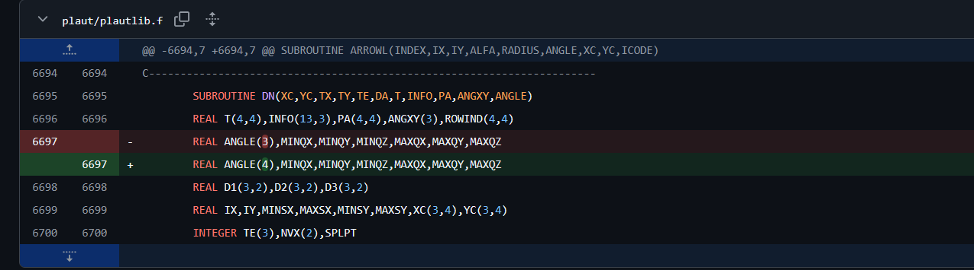
Change 3 to 4.

PART III – Set environment variables
- Open C:\MinGW\msys\1.0\msys.bat as administrator, and type the following:
touch .bashrc
- Open the newly created .bashrc file in a text editor. Enter the following (instead of USER_NAME, write the computer username; find out by typing whoami in msys.bat) and save:
source /home/USER_NAME/auto/07p/cmds/auto.env.sh
(Basically you need to get the file …env.sh).
- Open C:\MinGW\msys\1.0\etc\profile in a text editor. Add the following line at the end and save:
. ~/.bashrc
- Open C:\MinGW\msys\1.0\home\USER_NAME\auto\07p\cmds\auto.env.sh in a text editor. Uncomment line 8, i.e., remove the ‘#’ at the beginning of the line. Line 8 should look like this (If Python27 is written, change it to Python26):
PATH="/c/Python26:/bin:/c/Program Files/gfortran/bin:$PATH"
- Go to Control Panel > System and Security > System > Advanced System Settings. Go to Advanced tab, click on Environment Variables… In the System Variables list, click on Path, then click Edit… Click New and add C:\MinGw\bin and C:\MinGW to the list, if they are not already there.
PART IV – Check if it works
- Open C:\MinGW\msys\1.0\msys.bat as administrator, and type the following:
cd auto/07p/demos/ab
@r ab
@pp
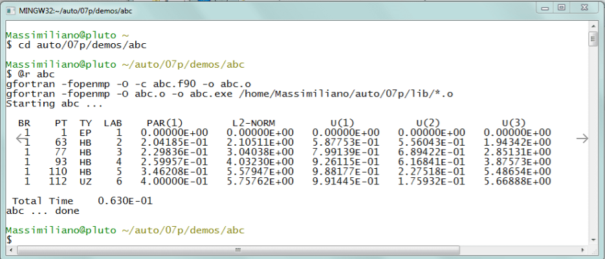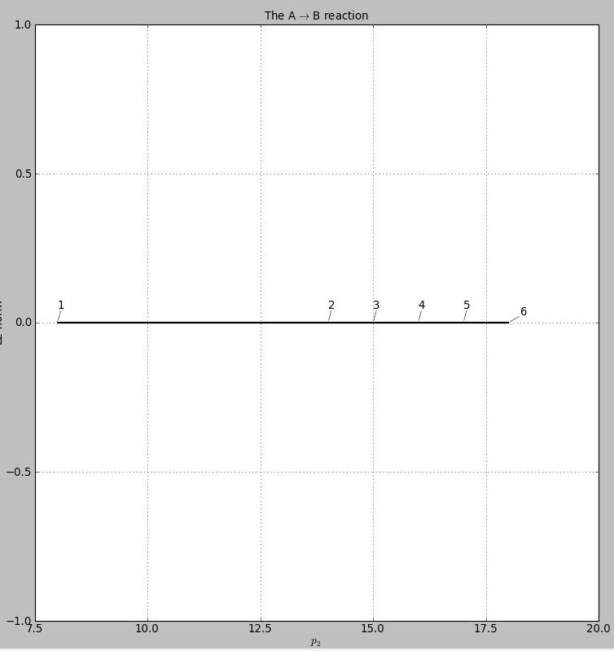
If the first output comes, Auto works. If the second output comes, the graphical interface to plot bifurcation diagrams works.

PART V – Run Auto-07p
- The easiest way to run Auto is through Python codes. Open C:\MinGW\msys\1.0\home\USER_NAME\auto\07p\python\auto.py in a text editor. Add the following lines in the beginning and save:
import os
os.chdir(“Directory_for_all_AUTO_programs”)
- Create a shortcut for the file auto.py on your desktop. To run Auto, just double click the shortcut. A Python command line interface for Auto will open. It will look like this:
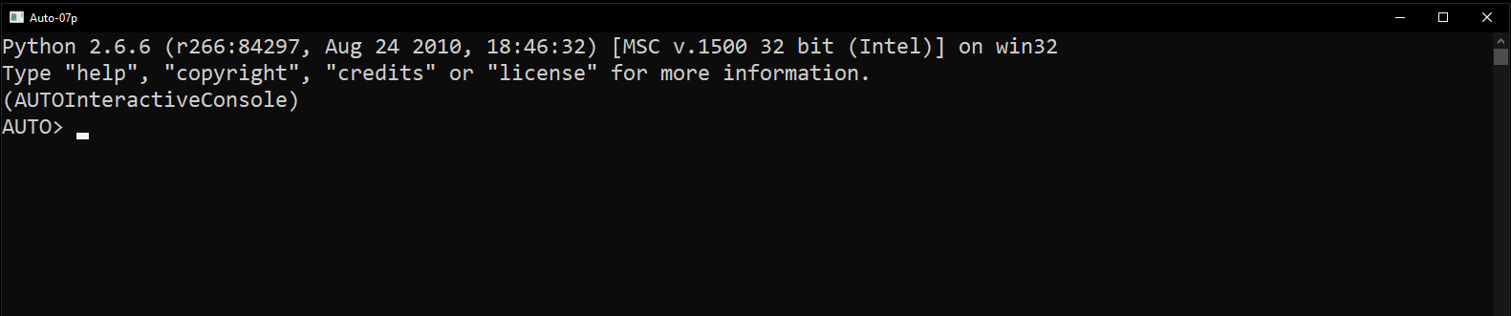
- Download the manual for Auto from this link: https://depts.washington.edu/bdecon/workshop2012/auto-tutorial/documentation/auto07p%20manual.pdf
Follow the manual to run Auto using Python commands.

____________________________________________________________________

